PUBLI EDITORIAL in L’Etudiant.fr
with SOCIAL NETWORK
2016

Part I – Publi editorial

Files to be provided in attachement :
- this document dully filled in,
- your visual/logo : format 100x100 pixels (your company logo can be integrated directly into a visual of your choice),
- At least one illustration picture of your text (or more),
- the url link/s within your text.

Example on a section homepage:
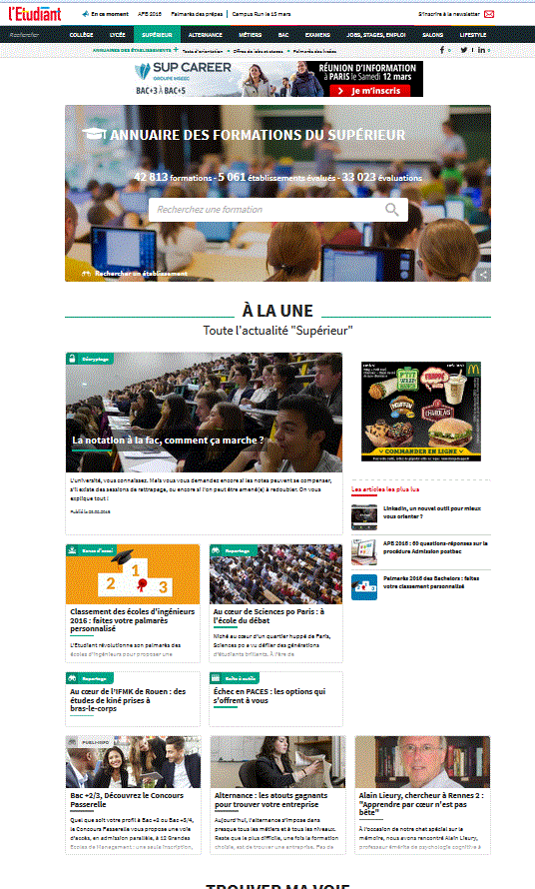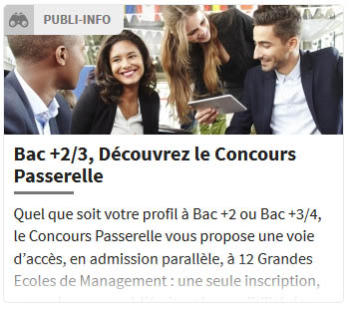
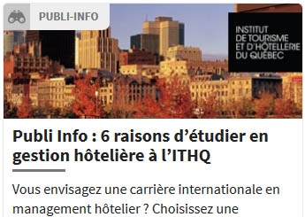

Publieditorial with integrated logo on the picture, on demand.

Then of the website page :
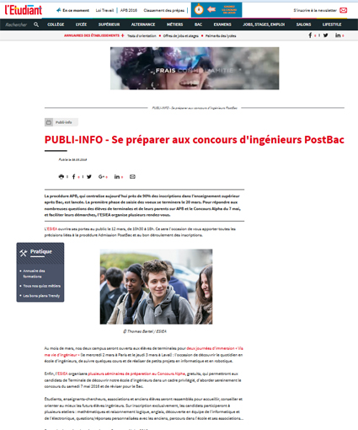
Publi editorial title (50 symbols max, spaces included, preceded by) :

Publi editorial : -

Chapeau (400 symbols max, spaces included) :

Your presentation text (5000 symbols max, spaces included) – should you wish different bold symbols, thanks for providing said part in another Word document with due info:

Photo credits obligatory :

1- Photo © First name Last name / source
2- Photo © First name Last name / source

With one or two JPG images OR an MP4 video (3 minutes maxi).

Choose a Pack (seen with your contact at l’Etudiant) :

Studies (homepages of sections : Higher Education, Highschool, Junior school) - Professions – Exams
Jobs, internships, Employment – Apprenticeship - Life-style
Part II - Social network on FaceBook :
Title (90 symbols max, spaces included) :

Text (250 symbols max, spaces included) :

A JPG image : format 16/9, with at least 600px large. The image must not should not contain text.

Please return this completed form with the required files to :
traffic-web@letudiant.fr

(20/04/16-gb)

